PWANI TEKNOWGALZ APPLICANT TO PROGRAM PROJECT
TEAM E
DATA ANALYTICS

TEAM MEMBERS

- MWAMIZE KHALFAN
- ASUQUO PRECIOUS ENEFIOK
Team Member | Contribution | Tools
Mwamize Khalfan | Database design and Development  Exploratory Data Analysis  Findings and Recommendations documentation(Story telling)  Power BI Dashboard development  Documentation | SQLite  Python  Pandas  Matplotlib  Microsoft PowerBI  Microsoft Word  Github
Asuquo Precious Enefiok | Data Preparation  Quality Checks  Data Cleaning | Microsoft Excel

TABLE OF CONTENTS
Contents
TEAM MEMBERS i
TABLE OF CONTENTS ii
LIST OF FIGURES iv
EXECUTIVE SUMMARY 1
BUSINESS UNDERSTANDING 2
About the organization 2
Problem Statement 2
Proposed Solution 2
Project Objectives 3
General Objective 3
Specific Objectives 3
TECHNOLOGIES USED AND PROJECT LINKS 4
Technology used 4
Project Links 4
DISCOVERY 5
Data understanding 5
Database Overview 5
DATA PREPARATION 6
Data Quality Checks 6
Data Cleaning 6
Data Consolidation 7
EXPLORATORY DATA ANALYSIS 9
Applicant and Application Analysis 9
Enrollment Analysis 10
Drop-off analysis 10
Findings 12
Applicants and applications analysis 12
Enrollment analysis 12
Drop Off Analysis 12
Recommendations 13
DASHBOARD DESIGN 14
Dashboard Design Objectives 14
Dashboard Layout 14
Main Dashboard Sections 14
Organization Branding 15
Key Performance Indicators (KPIs) 15
Interactive Filters 15
Applicant Analysis Visualizations 16
Enrollment Analysis Visualizations 16
Applicant-to-Program Funnel 16
Insights and Recommendations 17
Current Reach and Target Visualization 17
Dashboard Navigation and User Guidance 17
Visual Design and Color Scheme 18
Dashboard Design Outcome 18
USER GUIDE 19
Using the Filters 19
Clearing Filters 19
Interpreting the Applicant Charts 19
Interpreting the Enrollment Charts 19
Interpreting the Applicant-to-Program Funnel 20
Insights and Recommendations 20
How to Use Page 20
Recommended User Workflow 21
LIMITATIONS 22
Challenges and Solution 23
Key Outcomes 24
ASSUMPTIONS 25
CONCLUSION 26

LIST OF FIGURES

Figure 1: Database Image 5
Figure 2: Data Checks 6
Figure 3: Data Cleaning 7
Figure 4:Data Consolidation 7
Figure 5: Consolidated Dataset 8
Figure 6: Applicants by program bar chart 9
Figure 7: Enrollment by Counties 10
Figure 8: Drop off analysis chart 11
.Figure 9: Dashboard 17
Figure 10: How to use page 20

EXECUTIVE SUMMARY
Pwani Teknowgalz is a Mombasa based women-led nonprofit organization that has trained over 6800 young women in STEM and digital skills since 2015, out of more than 20,000 applicants. The organization has set a 2026 goal to raise the share of applicants it can reach from roughly 15% to 50%. This project aims at helping Pwani Teknowgalz understand its applicant-toparticipant funnel, identify where and why the capacity is lost and they will track progress towards this goal by a reusable interactive dashboard that is maintainable by the staff.

BUSINESS UNDERSTANDING

About the organization
It was founded in 2015/2016 originally to close the gender gap in STEM at the Technical University of Mombasa. It has since grown into a recognized digital innovation hub (selected under Kenya’s DigiKen initiative) delivering programs including STEM Café’ Kenya across counties including Mombasa, Nairobi, Kisumu and Lamu.

Problem Statement
Pwani Teknowgalz has received over 20,000 program applications since inception but has only been able to enroll about 15% of applicants (6,800 young women). The organization has publicly committed to reaching 50% applicants by the end of 2026. At the present, applicant, enrollment and program data appear to be tracked separately across multiple programs and counties with no unified view of where the funnel breaks down or what resource constraints are a limiting capacity. Without this visibility it is difficult for the organization to prioritize outreach, allocate resources or make an evidence-based case to funders.

Proposed Solution
This project aims at developing a centralized analytics solution that consolidates applicant, enrollment, program and resource data into a single clean dataset from the database. Moreover, it will provide an interactive dashboard maintainable by the organization staff that will enable the organization to monitor applicant journey, identify enrollment bottlenecks, understand who is being underserved, track resource constraint and measure progress towards its 2026 goal of enrolling 50% applicants.

Project Objectives

General Objective
- The main goal of this project is to help the organization reaching and enrolling 50% applicants by the end of 2026.

Specific Objectives
- To Consolidate and clean applicant and program-participation data across Pwani Teknowgalz’s programs and counties into a single analyzable dataset.
- To quantify the applicant to enrollment funnel and identify the stages, programs or regions with the largest drop off.
- To identify patterns in who is and who is not being reached relative to the applicant pool.
- To surface resources or capacity constraints that limits how many applicants can be enrolled.
- To build an interactive dashboard that lets staff track progress towards the 2026 goal.
- To hand over a lightweight, non-technical process staff can use to keep the dashboard updated after the project ends.

TECHNOLOGIES USED AND PROJECT LINKS

Technology used
Technology/Tool | Purpose
SQLite | Database development and management
Microsoft Excel | Initial Data Preparation, inspection and cleaning
Python | Data Cleaning and Exploratory Data Analysis
Pandas & Matplotlib | Data Manipulation, Processing and Visualization
Microsoft Power BI | Interactive Dashboard Development and Visualization
Git & Github | Project repository Management

Project Links
Resource | Link
Github Repository | https://github.com/mize04/Pwani-Teknowgalz-applicant-to-Program-Project
Power BI Dashboard | Available in github repository main branch (https://github.com/mize04/Pwani-Teknowgalz-applicant-to-Program-Project/blob/main/pwani%20teknowgalz%20dashboard.pbix)
Jupyter Notebooks | Available in github repository main branch (analysis.ipynb)
Consolidated Dataset | Available in github repository main branch (consolidated_dataset.csv)
Project Video | https://drive.google.com/file/d/1zQFbKxzZZ7dRYKEhWzLEIU8LRTao1ldR/view?usp=drivesdk

DISCOVERY

Data understanding

Database Overview
Pwani Teknowgalz Organization uses an SQLite relational database to store applicant and enrollment information. The database supports monitoring of the organization’s recruitment pipeline from application through enrollment. It consists of 6 relatable tables designed to minimize redundancy while maintaining data integrity using primary and foreign keys.
Data Generation summary
Synthetic data was generated using Python to simulate realistic organizational records.
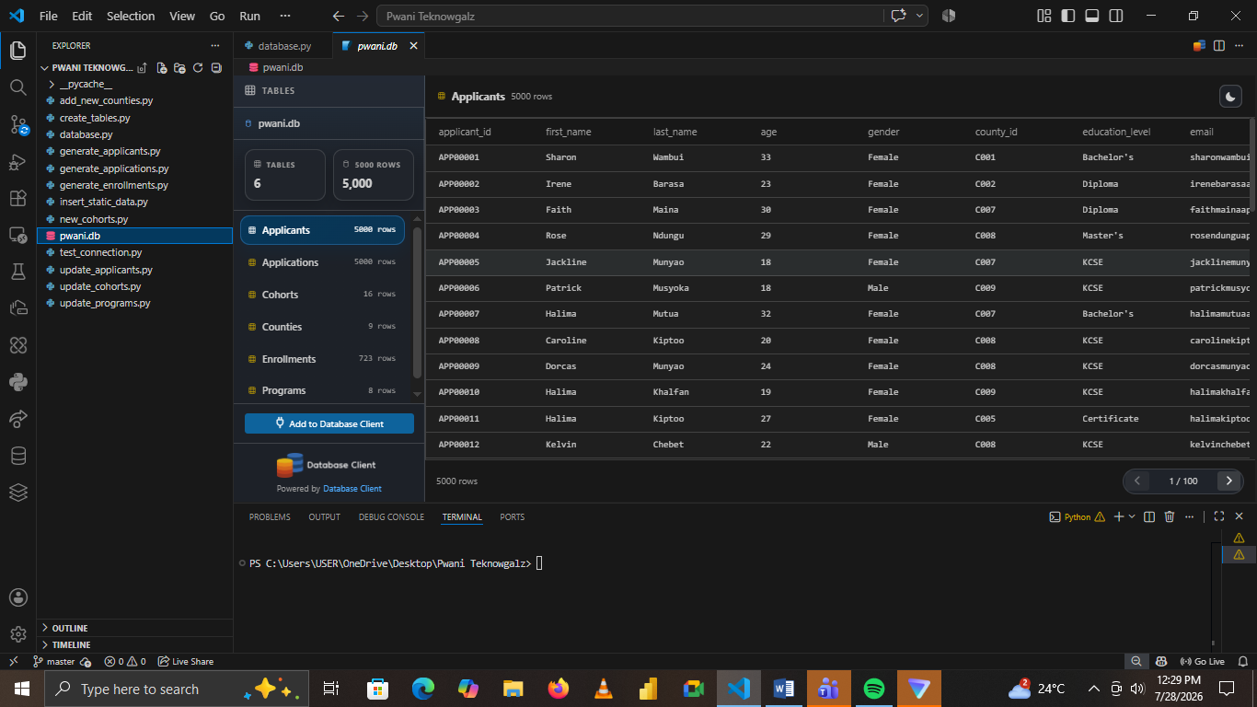
Figure 1: Database Image

DATA PREPARATION
This stage involved transforming the raw datasets into a clean, consistent and analysis-ready format. This stage was conducted before dataset consolidation and analysis.
The main activities included data cleaning, data quality assessment and data consolidation.

Data Quality Checks
In this stage, we checked for duplicate records, consistency of the data and missing values. We found some issues in applicants and applications data. From this stage we proceeded to Data Cleaning.
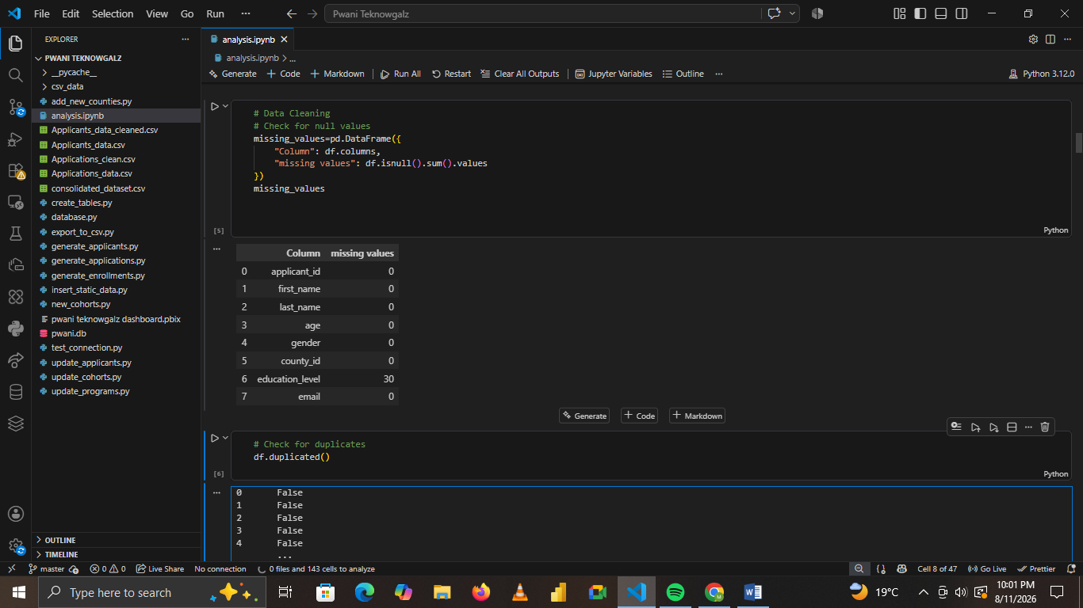
Figure 2: Data Checks

Data Cleaning
In this stage, after inspecting the dataset, Applicants data and Application data was messy. They contained trailing spaces, inconsistent case format, null entries and leading spaces.
Applicants data was cleaned using a power query in excel while we used python to clean Applications data where the null drop off reasons were replaced in accordance to the application status.
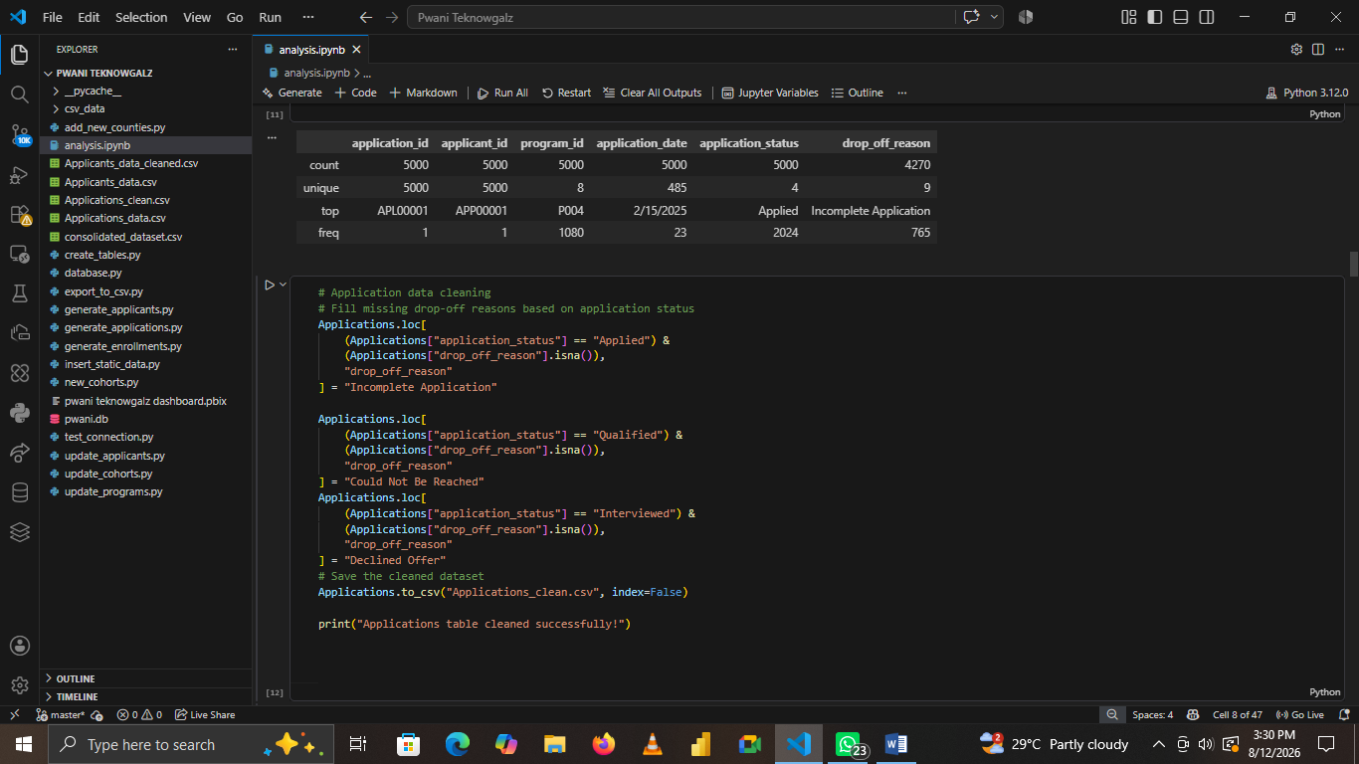
Figure 3: Data Cleaning

Data Consolidation
After the individual datasets had been cleaned and validated, the required datasets were consolidated using SQL.
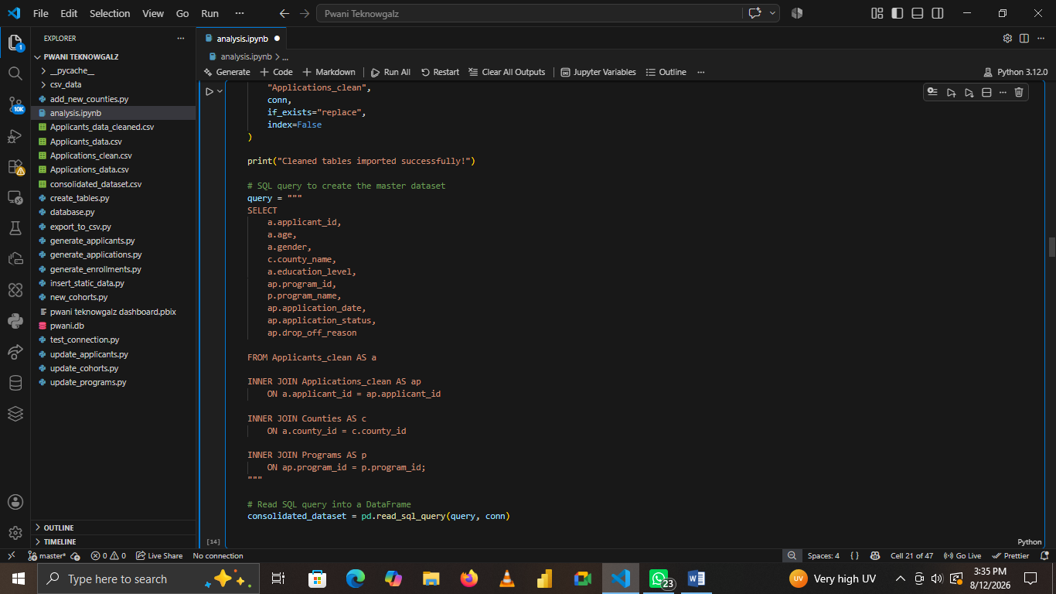
Figure 4:Data Consolidation
The main tables used were Applicants, Applications, Programs, and Counties. SQL Inner Join was used to connect applicants to their corresponding applications, programs and counties using their respective identifiers.
The consolidated dataset had the following columns: Applicant ID, Age, Gender, County Name, Education level, Program name, Application date, Application status and drop off reason. Later on in the analysis while building the dashboard Year column was deduced from application date.
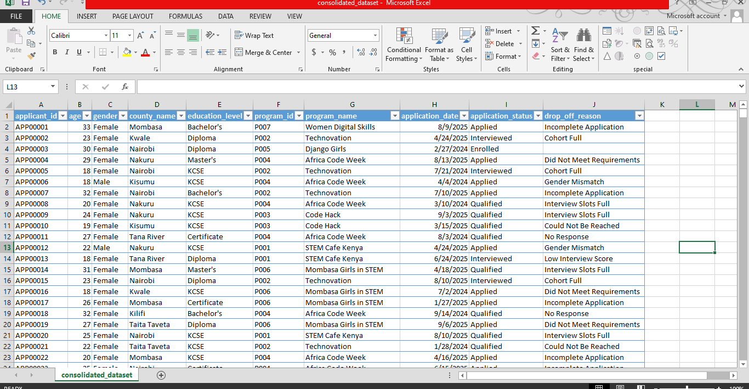
Figure 5: Consolidated Dataset

EXPLORATORY DATA ANALYSIS
Exploratory Data Analysis (EDA) was conducted after the data preparation and consolidation stages to understand the characteristics of the applicant population, application progression, enrollment patterns and applicant drop-off.
Python was used to perform the analysis and generate visualizations. The main libraries used were Pandas and Matplotlib.
The EDA was divided into three main areas:
- Applicant and application analysis
- Enrollment analysis
- Drop-off analysis
The results of the EDA were later used to develop the Power BI dashboard and formulate recommendations.

Applicant and Application Analysis
In this part:
The distribution of applicants across education level, programs and counties was analyzed using a horizontal bar chart.
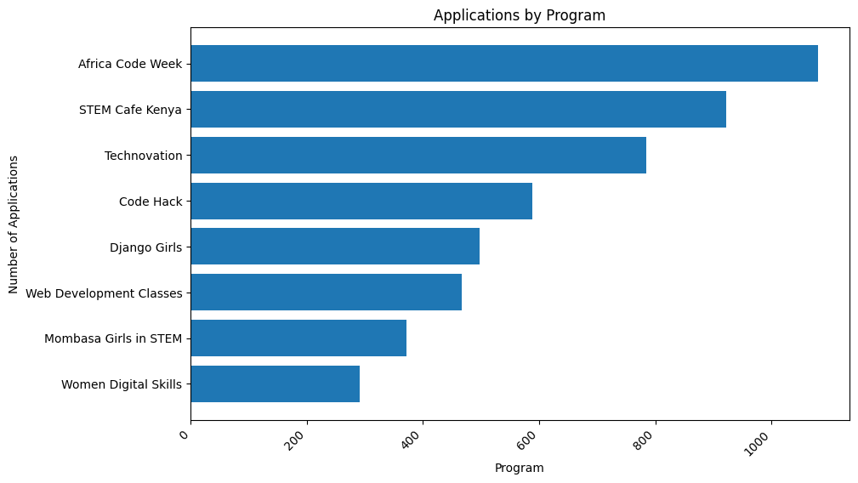
Figure 6: Applicants by program bar chart

The analysis showed differences in program popularity, geographical reach of each county and age distribution.

Enrollment Analysis
In this section an analysis was done to identify the number of applicants who successfully progressed through the recruitment process. This analysis focused on the overall enrollment of applicants, enrollment by program, enrollment by county, enrollment by age and enrollment by education level.
Horizontal bar charts were used
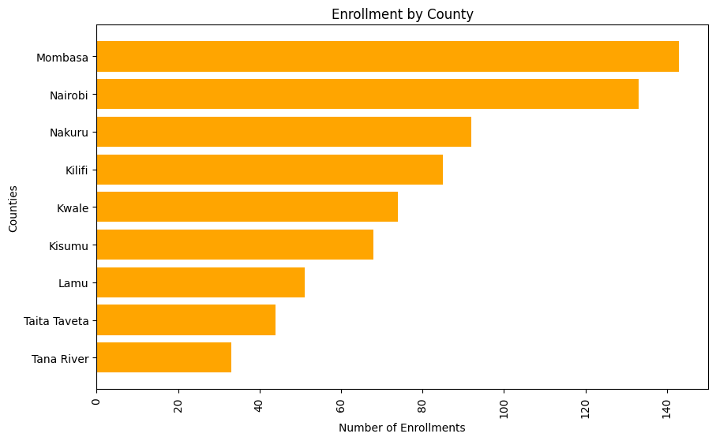
Figure 7: Enrollment by Counties
Enrollment was analyzed across programs, counties and age to determine how many applicants successfully enrolled in each program, county and age group.

Drop-off analysis
Drop-off analysis was conducted to understand why applicants did not progress through the recruitment process.
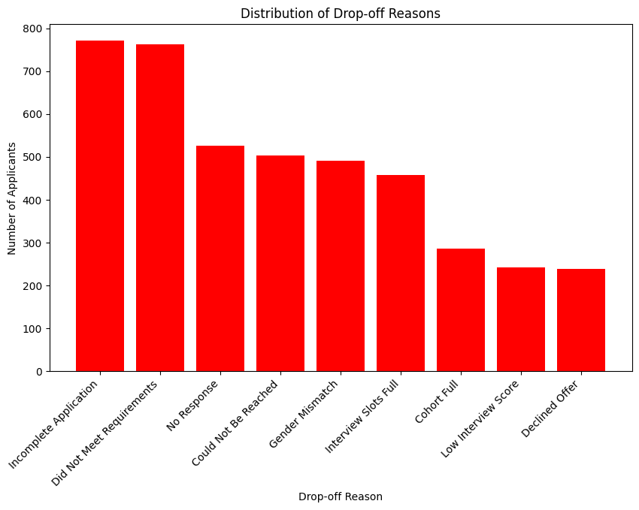
Figure 8: Drop off analysis chart
The analysis examined the drop off reason variable and calculated the frequency and percentage associated with each reason.

Findings

Applicants and applications analysis
- The analysis showed differences in program popularity, with Africa Code Week among the programs receiving the highest number of applications.
- Mombasa recorded the highest number of applicants while Tana River recorded the lowest applicant representation among the counties in the dataset.
- The analysis showed that applicants aged 18–28 represented a larger proportion of applicants.

Enrollment analysis
- There were 723 enrolled participants out of 5,000 applicants. This resulted in an overall enrollment rate of approximately: 14.46%
- Africa Code Week recorded highest enrollment rate while Women Digital Skills had the least enrollment rate
- Mombasa recorded the highest number of enrollments while Tana River recorded the lowest among the counties in the dataset.
- The analysis showed that applicants aged 18–28 represented a larger proportion of enrollments.

Drop Off Analysis
The analysis identified several reasons why applicants did not progress to enrollment.
The main reasons included:
- Incomplete applications
- Did not meet requirements
- Applicant could not be reached
- Gender mismatch
- Interview slots being full
The prominent reason why Applicants were dropped off is due to Incomplete applications based on the analysis.

Recommendations
Based on the findings above, the following recommendations are proposed:
- The organization should introduce automated reminders for applicants who have started but not completed their applications since most applicants were not enrolled because they did not complete their application.
- Program requirements should be clearly displayed before and during the application process.
- Where possible, the organization should maintain alternative communication channels for shortlisted applicants who cannot be reached through their primary contact.
- The organization should strengthen recruitment and awareness activities in counties with relatively low applicant representation, particularly Tana River while ensuring that high-demand areas such as Mombasa have sufficient resources to accommodate applicant demand.
- Programs receiving high application numbers (Africa Code Week) should be increased their capacity to accommodate more.
- Since applicants aged 18–28 form a larger proportion of the applicant population, recruitment and engagement activities could include interactive technology-related activities such as Tech competitions.

DASHBOARD DESIGN
An interactive dashboard was designed and developed using Microsoft Power BI to present the results of the applicant, enrollment, and drop-off analysis in a clear and accessible format.
The dashboard was designed to support Pwani Teknowgalz in monitoring applicant reach, enrollment performance, program demand, geographical reach and applicant progression toward the 50% target.

Dashboard Design Objectives
The dashboard was designed to achieve the following objectives:
- Provide a summarized view of applicant and enrollment performance.
- Track progress toward the 50% target.
- Compare applicants and enrolled participants across programs and counties
- Visualize the applicant journey from application to enrollment.
- Allow users to interactively filter the analysis.
- Present key insights and recommendations alongside the analysis.
- Provide a simple and user-friendly interface for organizational staff.

Dashboard Layout
The dashboard follows a structured layout consisting of a sidebar, KPI section, visualizations, applicant funnel and insights and recommendations section.
The layout was designed to guide users from a high-level overview of performance to more detailed analysis.

Main Dashboard Sections
The dashboard consists of:
- Organization branding and navigation
- KPI cards
- Interactive filters
- Applicant analysis charts
- Enrollment analysis charts
- Applicant-to-program funnel
- Drop-off analysis
- Insights and recommendations
- Current reach indicator

Organization Branding
The left-hand sidebar contains the Pwani Teknowgalz logo and organizational branding.
The branding section was included to make the dashboard aligned with the organization and to clearly identify the dashboard's purpose.
The sidebar also contains an introductory description of the dashboard and navigation controls.

Key Performance Indicators (KPIs)
A series of KPI cards was placed horizontally across the top of the dashboard to provide an immediate overview of performance.
The KPI cards display:
- Total Applicants
- Total Enrolled
- Enrollment Rate
- Total Drop-offs
- Target Reach
- Current Reach
These indicators allow users to understand the overall recruitment and enrollment situation before examining the detailed visualizations.
The Target Reach KPI represents the organization's 50% target, while the Current Reach indicator provides a visual representation of progress toward that target.

Interactive Filters
A filter section was placed on the left side of the dashboard.
The available filters include:
- Year
- County
- Program
- Education Level
These slicers allow users to explore specific sections of the dataset without having to examine the entire dataset at once.
For example, a user can select a particular county and program to examine how many applicants were received and how many were successfully enrolled.
A Clear Filters button was also included to allow users to quickly return to the default dashboard view.

Applicant Analysis Visualizations
The first group of charts focuses on applicant distribution.
The dashboard includes visualizations for:

Applicants by Program
Applicants by County
Applicants by Age

Enrollment Analysis Visualizations
Enrollment by Program
Enrollment by County
Enrollment by Age
The enrollment charts use a darker green color scheme to distinguish them from the applicant charts.

Applicant-to-Program Funnel
A funnel chart was incorporated at the bottom of the dashboard to visualize the applicant journey.
The funnel represents the progression through the following stages:
Applied → Qualified → Interviewed → Enrolled
The funnel provides a visual representation of how the number of applicants decreases as they move through the recruitment process.
This helps users identify the stages where the greatest applicant losses occur.

Insights and Recommendations
An Insights and Recommendations section was included on the dashboard to connect the analysis to practical actions.
The section summarizes important findings from the analysis and provides recommended actions for the organization.

Current Reach and Target Visualization
A gauge visualization was used to represent the organization's progress toward the 50% target.
The gauge displays the current enrollment/reach percentage against the target, allowing users to quickly assess the remaining gap.
This visualization is particularly useful for management because it provides an immediate indication of progress toward the organization's goal.

Dashboard Navigation and User Guidance
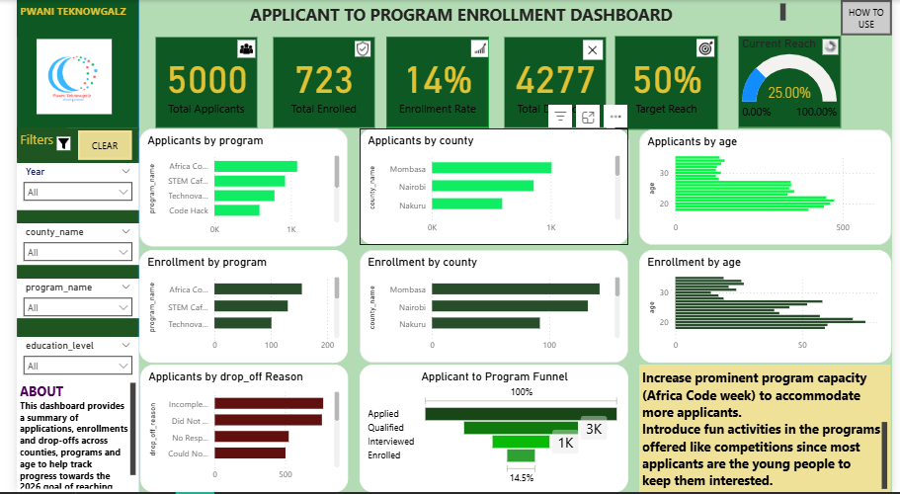
.Figure 9: Dashboard
The page provides instructions on how users can:
- Apply filters.
- Interpret KPI cards.
- Navigate the dashboard.
- Clear filters.
- Interpret the charts.
- Understand the applicant funnel.
This feature was included to ensure that non-technical staff can use the dashboard without requiring extensive technical training.

Visual Design and Color Scheme
The dashboard uses a consistent green-based color palette aligned with the organization's branding.
The color scheme was also used functionally to distinguish different types of information:
- Bright green: Applicant-related analysis.
- Dark green: Enrollment-related analysis.
- Gold/yellow: Insights, recommendations and important highlights.

Dashboard Design Outcome
The final dashboard integrates the project's analytical outputs into a single interactive decision-support tool.
It enables users to move from a high-level overview of applicant and enrollment performance to detailed analysis by year, county, program and age
The dashboard therefore provides Pwani Teknowgalz with a centralized platform for monitoring applicant reach, enrollment performance, applicant progression, and drop-off patterns while supporting data-driven decision-making toward the 50% target

USER GUIDE

Using the Filters
The dashboard contains interactive slicers on the left side.
Users can filter the dashboard by:
- Year
- County
- Program
- Education Level
To apply a filter:
- Locate the required filter on the left sidebar.
- Click the drop-down arrow.
- Select the desired value.
- The dashboard visuals will automatically update based on the selection.
Multiple filters can be applied simultaneously to perform more specific analysis.

Clearing Filters
A Clear button is provided on the dashboard to help users quickly return to the default view.
To clear the selections:
- Click the Clear button.
- The applied filters are reset.
- The dashboard returns to its default view.
This makes it easier for users to perform several analyses without manually removing each filter.

Interpreting the Applicant Charts
The applicant charts show the distribution of applicants across different categories. The charts can be used to identify areas with high applicant demand and areas where applicant reach is relatively low.

Interpreting the Enrollment Charts
The enrollment charts show the distribution of successfully enrolled participants.

Interpreting the Applicant-to-Program Funnel
The funnel illustrates the progression of applicants through the recruitment process:
Applied → Qualified → Interviewed → Enrolled
The decreasing size of each stage represents the reduction in participants as they progress through the process. The organization can therefore identify where the largest reduction occurs and use this information alongside the project's findings and recommendations.

Insights and Recommendations
The Insights and Recommendations section summarizes important findings from the analysis and provides suggested actions for the organization.

How to Use Page
A dedicated How to Use page is included within the Power BI report. It provides a simple reference for users who may be unfamiliar with Power BI.
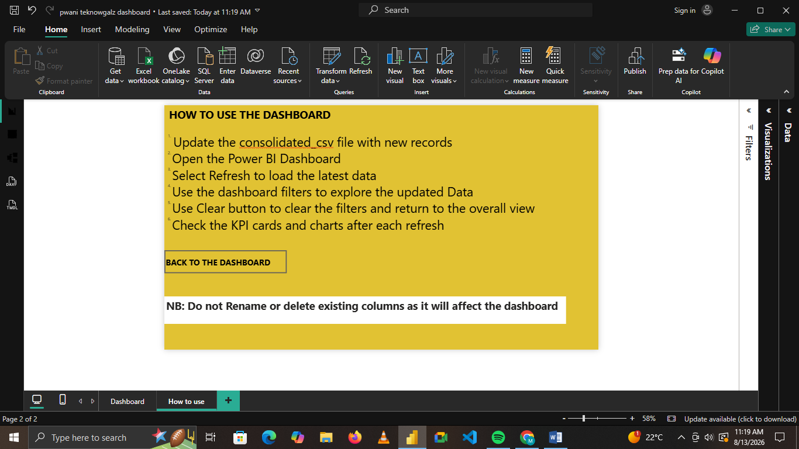
Figure 10: How to use page

Recommended User Workflow
For routine analysis, users can follow this workflow:
Open Dashboard → Review KPIs → Select Filters → Examine Applicant Charts → Examine Enrollment Charts → Review Funnel → Read Insights & Recommendations → Clear Filters

LIMITATIONS
Limited Historical Data - The analysis was based on the available historical records. Therefore, the findings may not fully represent long-term trends in applicant reach and enrollment if additional historical data becomes available in the future.
Not every variable or analysis conducted during the exploratory analysis was included as a dashboard visualization in order to maintain a clear and user-friendly interface.

Challenges and Solution
Challenge | Solution
Representing the applicant journey in the funnel | The application-status data contained stages such as Applied, Qualified, Interviewed and Enrolled. However, the statuses represented the applicant's current stage rather than cumulative progression. This meant that simply counting each status would produce an inaccurate funnel. A cumulative DAX measure was therefore developed so that applicants who reached a later stage were also counted in the earlier stages.
Funnel Stage Helper Table:
A challenge was encountered when developing the applicant-to-program funnel. The application-status field contained the stages Applied, Qualified, Interviewed, and Enrolled, but these values represented the applicant's current status. Therefore, directly counting each status would not produce a sequential funnel because an applicant who was enrolled would only appear under "Enrolled" rather than contributing to all stages they had passed through.
To address this, a separate Funnel Stages helper table was created containing the four required stages in the correct order. A DAX measure was then developed to calculate the number of applicants reaching each stage cumulatively.
For example, applicants with a status of Qualified, Interviewed, or Enrolled were included in the Qualified stage, while applicants with a status of Interviewed or Enrolled were included in the Interviewed stage. This allowed the dashboard to display the applicant journey as a sequential funnel without requiring major changes to the underlying database.

Key Outcomes
- Cleaned, checked, and consolidated the applicant and enrollment data.
- Identified key patterns in applicant reach, program demand, enrollment and drop-offs.
- Developed an interactive Power BI dashboard to make the findings easy to explore.
- Provided practical recommendations to improve applicant reach and enrollment.
- Created a user-friendly dashboard with a How to Use page for non-technical staff.
- Documented the full project workflow and made the project resources available through GitHub.

ASSUMPTIONS
The preliminary project information indicated that Pwani Teknowgalz had received approximately 20,000 applications and enrolled approximately 6,000 participants since its establishment. This was used as a historical reference point for understanding the organization's overall reach.
Based on these figures, the historical enrollment proportion is approximately 30%. Since the available dataset for the project contained approximately 5,000 applicants, the historical proportion was used as a reference when designing the Current Reach indicator in the dashboard.
This assumption was made because the available project dataset represents only a portion of the organization's broader historical applicant records.

CONCLUSION
This project successfully developed a data-driven applicant and enrollment analysis system for Pwani Teknowgalz.
Overall, the project provides Pwani Teknowgalz with a centralized and interactive tool for monitoring applicant reach and enrollment performance and supporting data-driven decision-making. The dashboard can also help the organization monitor progress toward its 50% target and identify areas requiring further intervention.
The combination of the cleaned dataset, database structure, analytical notebooks, Power BI dashboard, GitHub repository and project documentation provides a reproducible pipeline that can be extended as new applicant and enrollment data becomes available.

